Hattan (Home page)
{ https://hattan.co/?_ab=0&_fd=0&_sc=1&preview_theme_id=183249830202 }
1 - Custom Banner
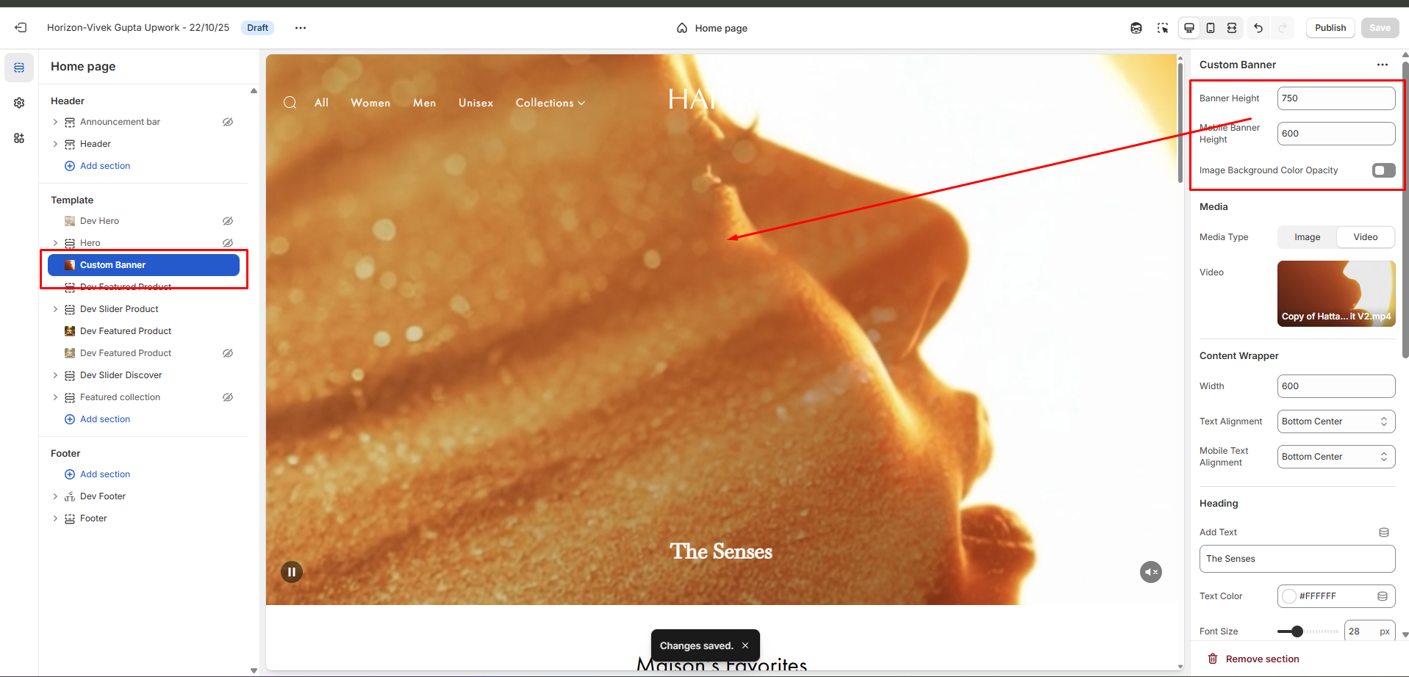
Admin can change the height of the banner for mobile and desktop screens and enable the overlay using the option marked above in the screenshot.
======================================================================
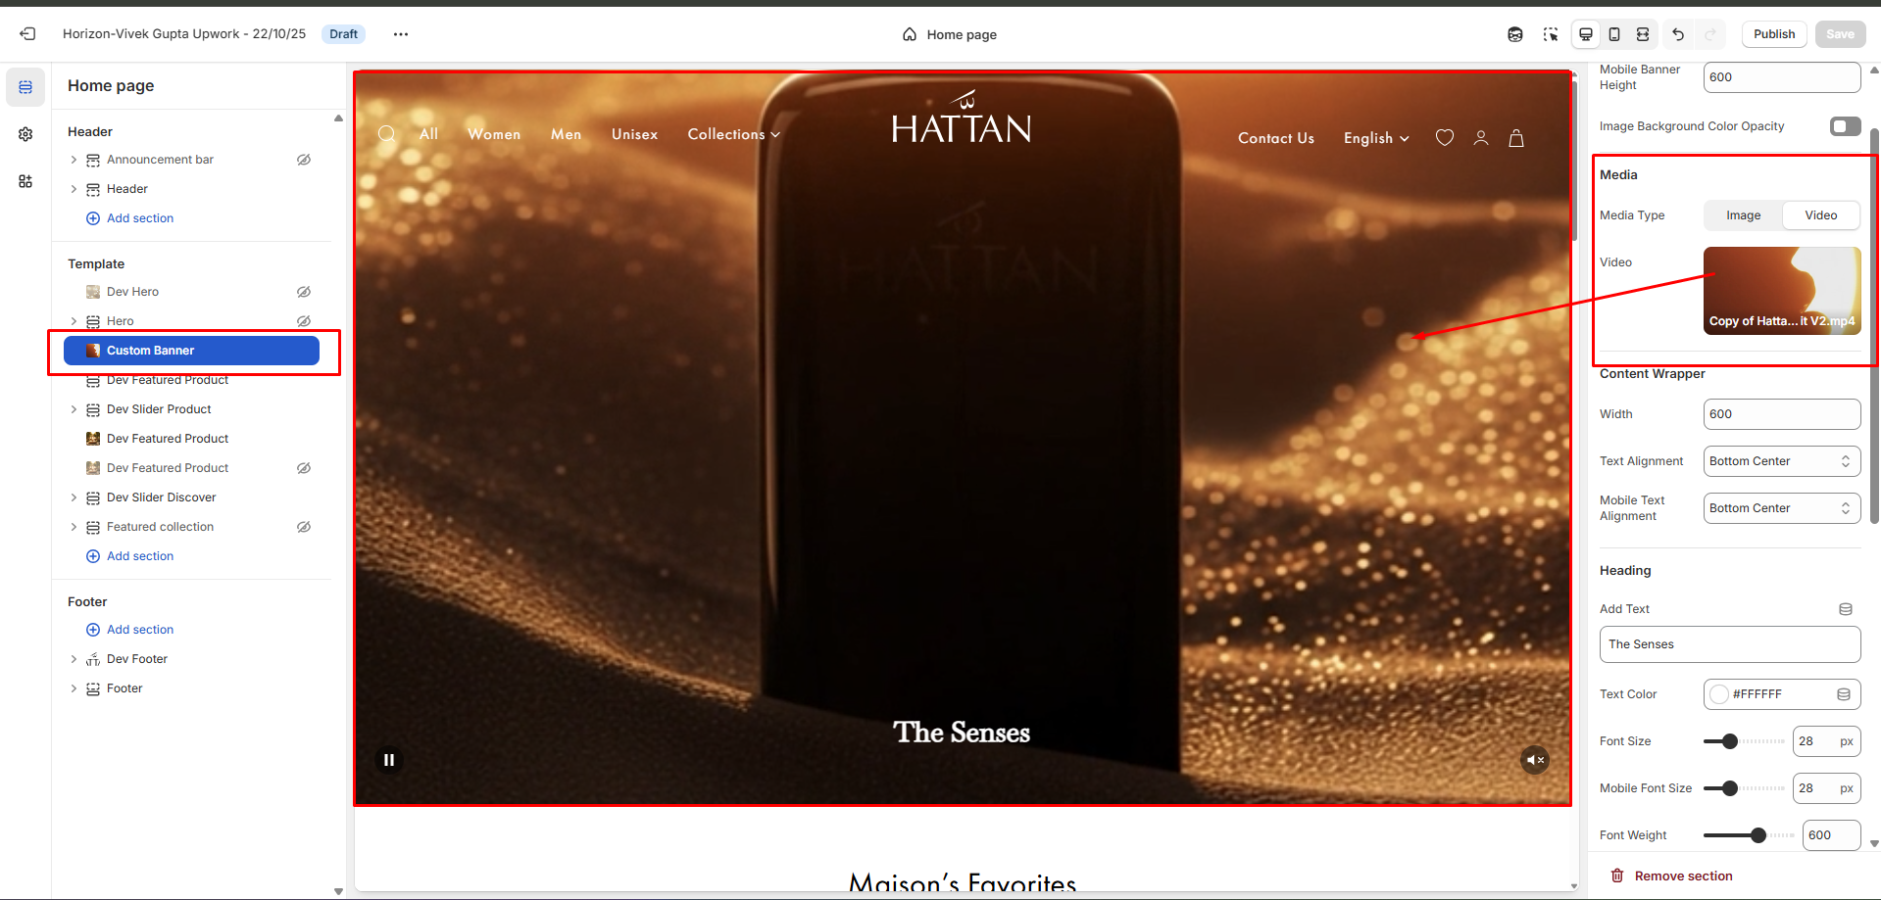
Admin can change the media type(image/video) using the option marked above in the screenshot.
======================================================================
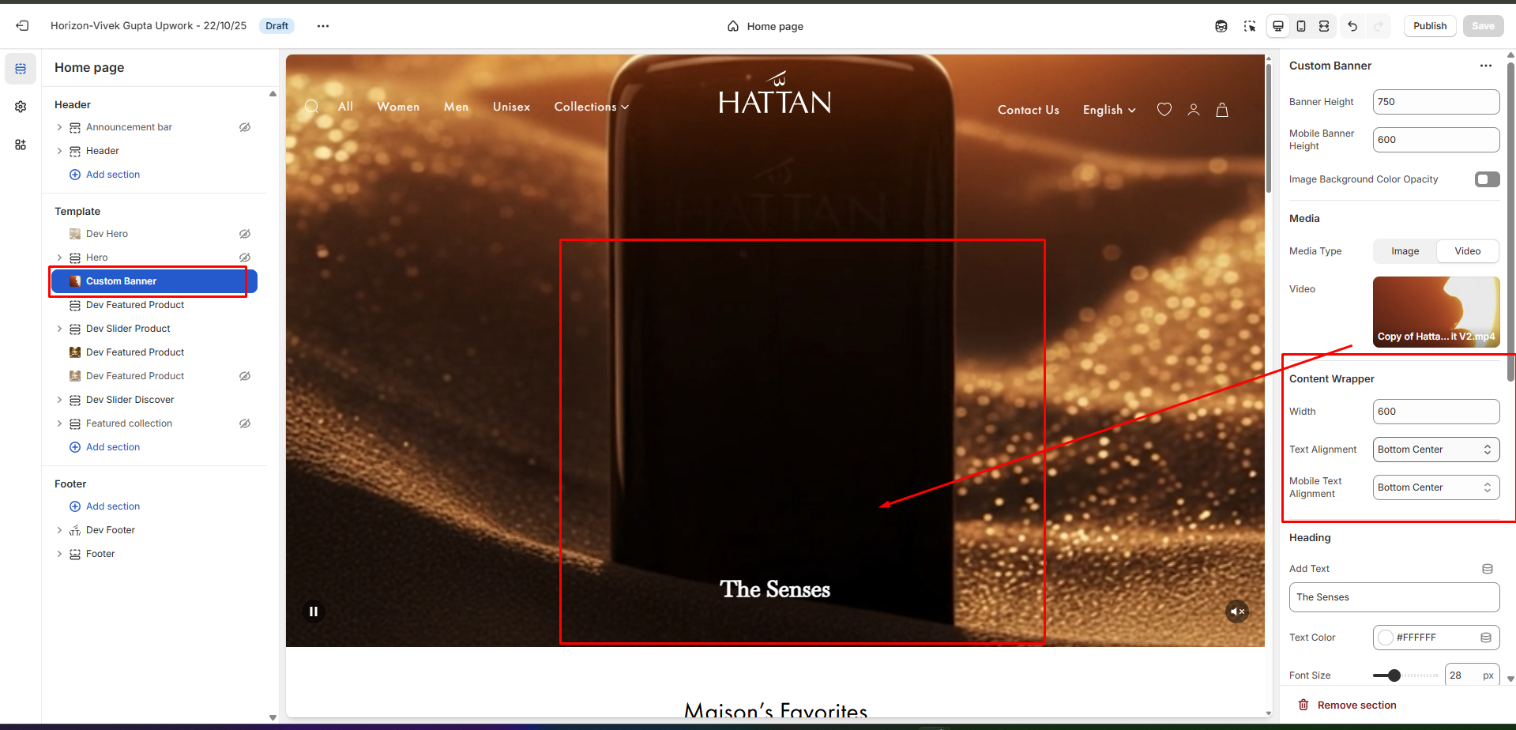
Admin can change the content width and the content position for both mobile and the desktop screens using the option marked above in the screenshot.
======================================================================

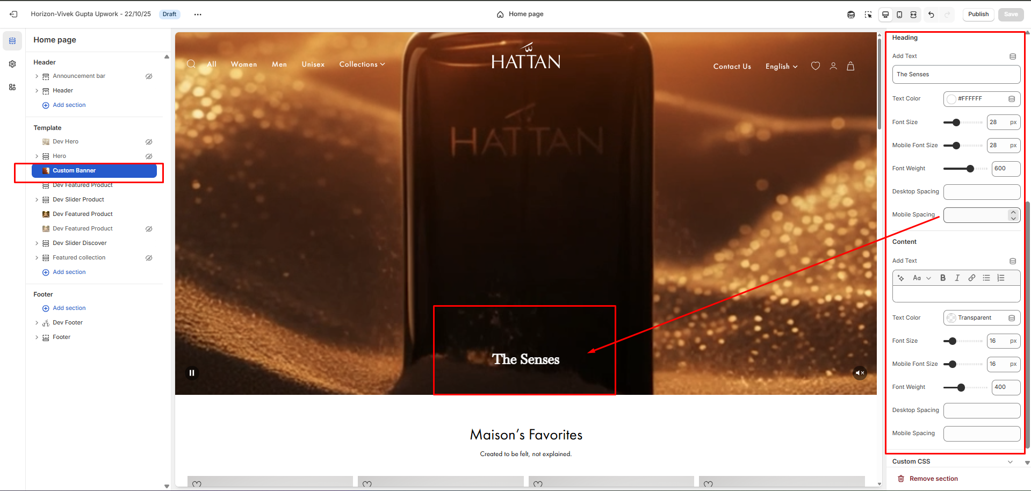
You can change the heading/text, font size, color, font weight and top/bottom spacing both for mobile and desktop screens using the option marked above in the screenshot.
======================================================================

2 - Dev Featured Product
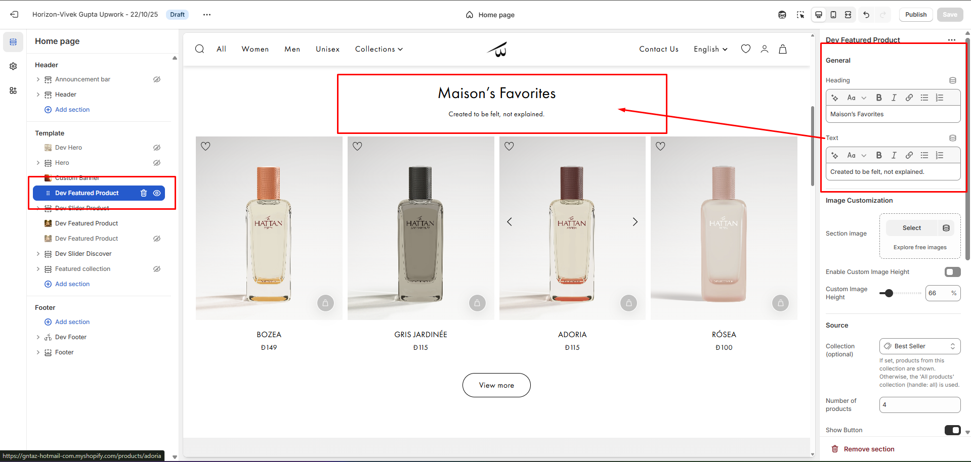
You can change the heading and text using the option marked above in the screenshot.
======================================================================

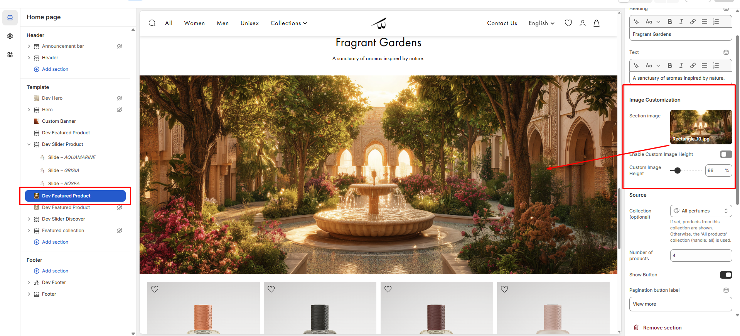
You can add the image and enable custom heights, as well as adjust the height of the image using the option marked above in the screenshot.
======================================================================

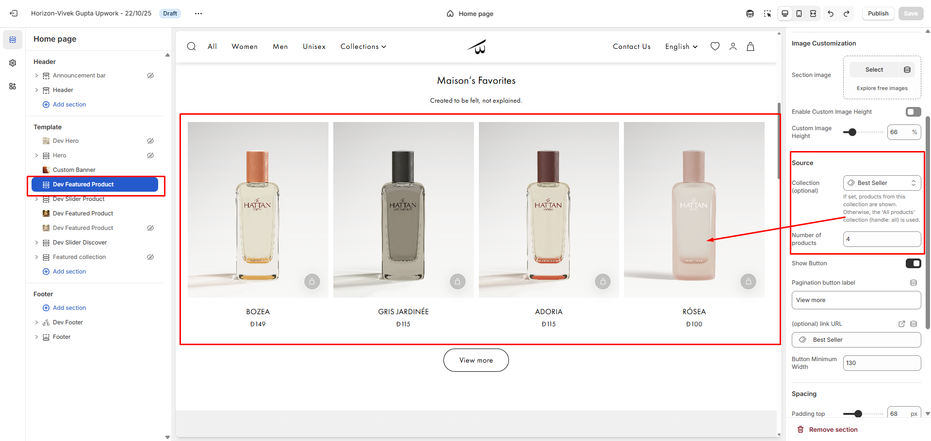
You can change the collection and the product count to display the products in a row using the option marked above in the screenshot.
======================================================================

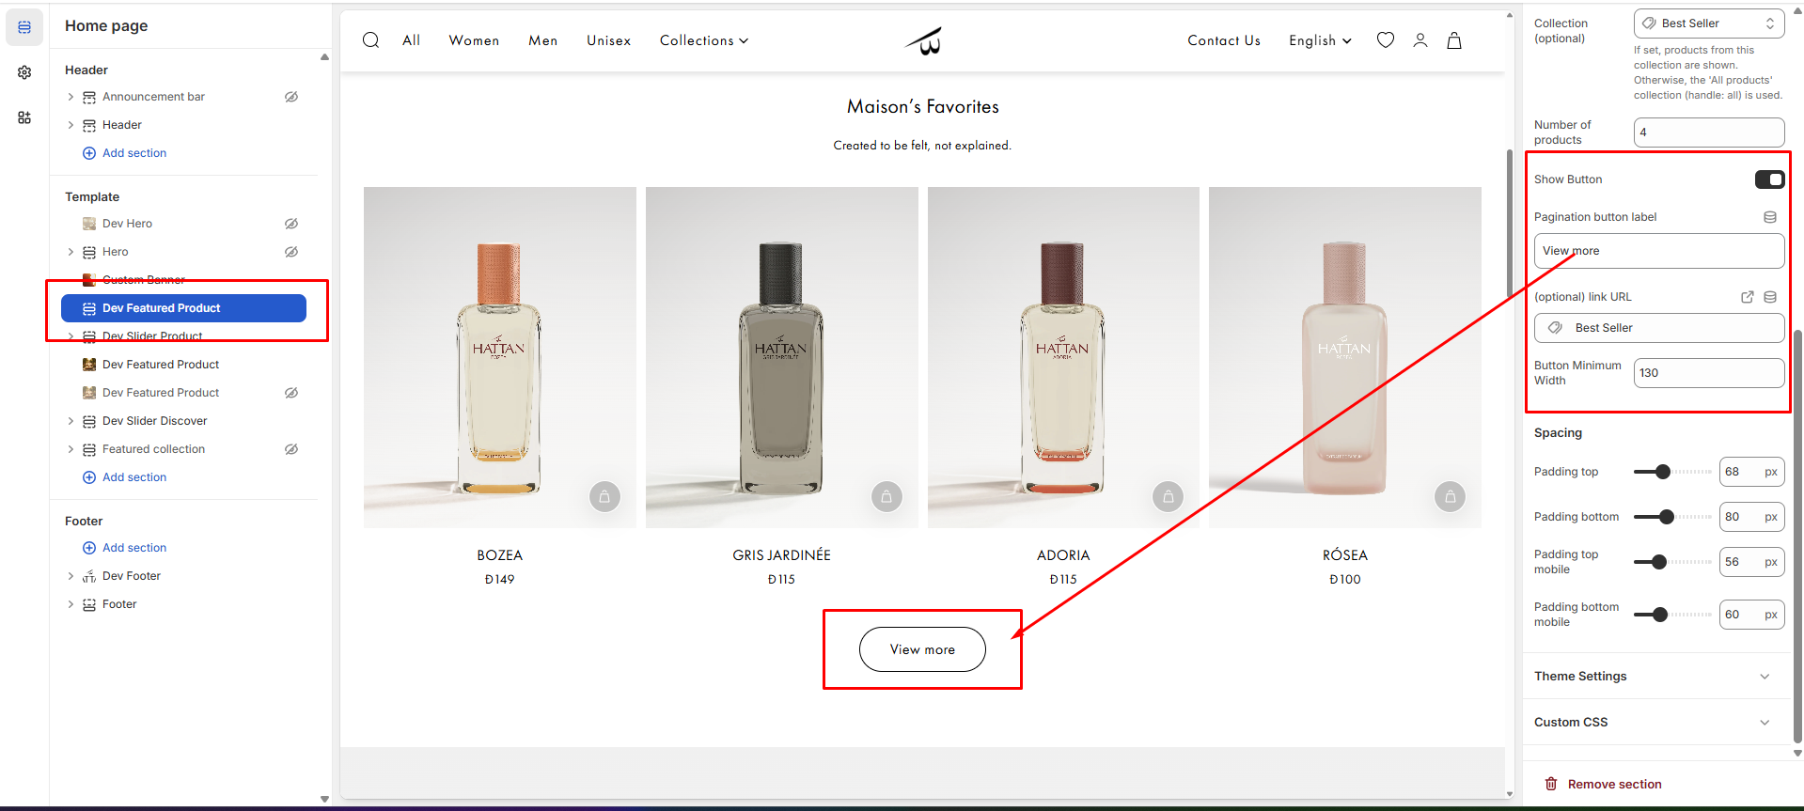
You can change the button label and the link using the option marked above in the screenshot.
======================================================================
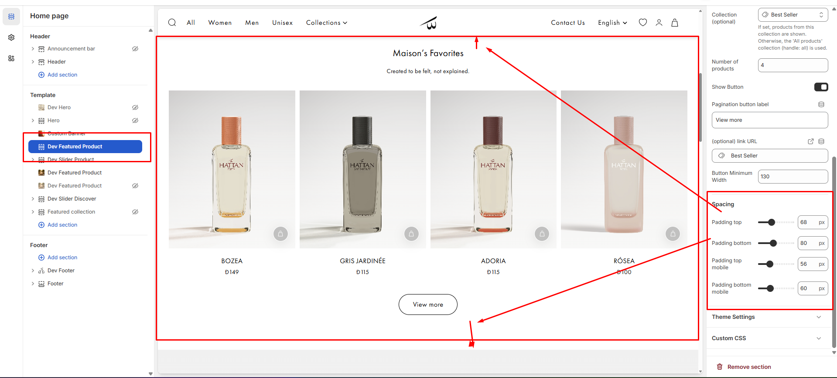
You can change the top/bottom spacing both for mobile and desktop screens using the option marked above in the screenshot.
======================================================================
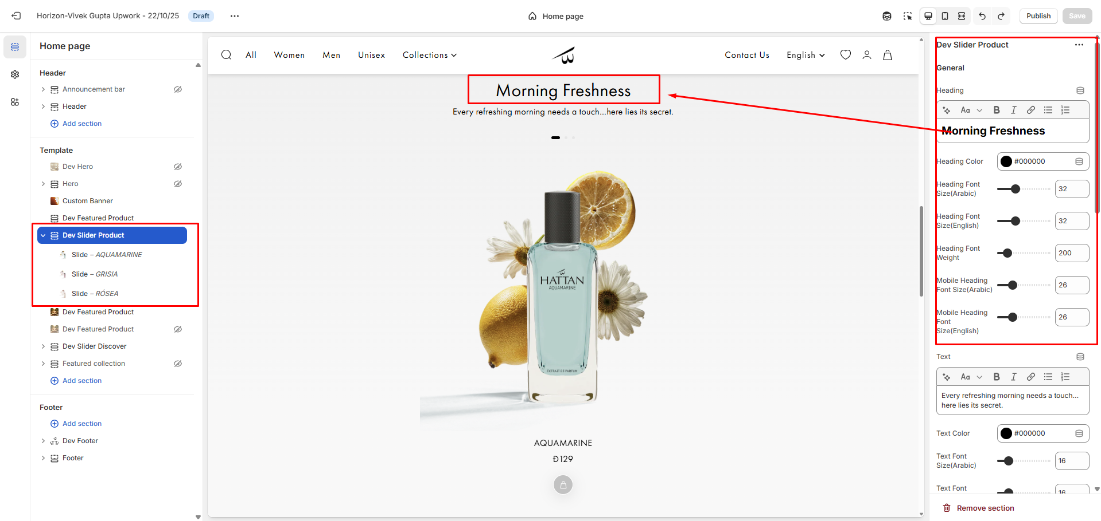
You can change the heading, font size, color, font weight and top/bottom spacing both for mobile and desktop screens using the option marked above in the screenshot.
======================================================================
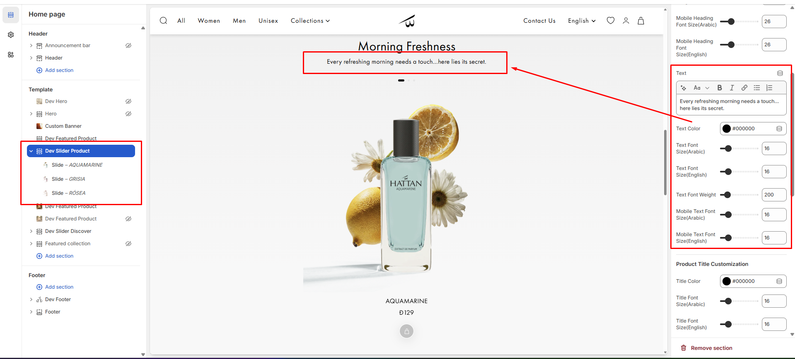
You can change the text, font size, color, font weight and top/bottom spacing both for mobile and desktop screens using the option marked above in the screenshot.
======================================================================
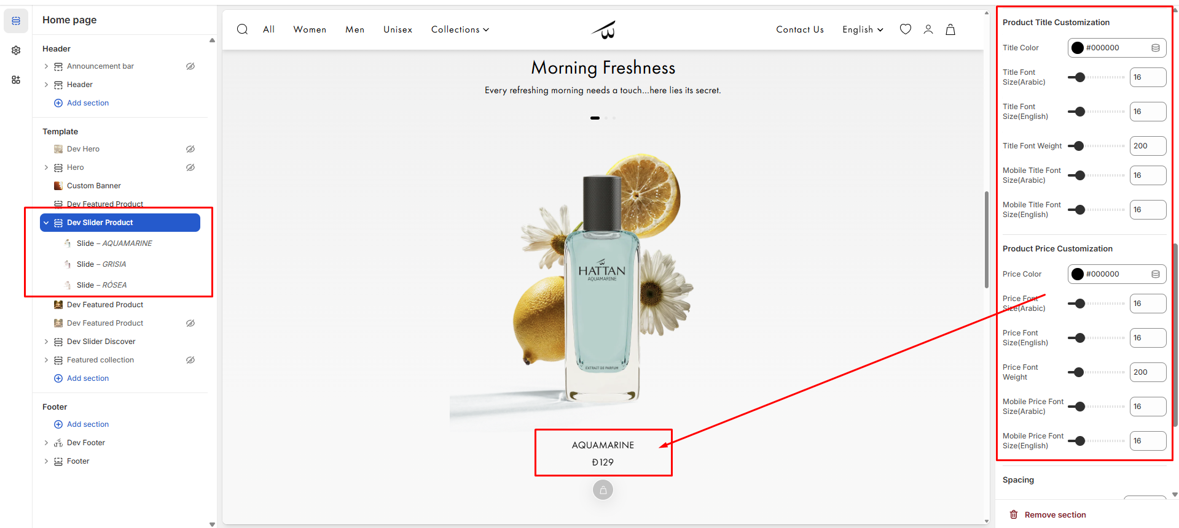
You can change the title/price font size, color, font weight and top/bottom spacing both for mobile and desktop screens using the option marked above in the screenshot.
======================================================================
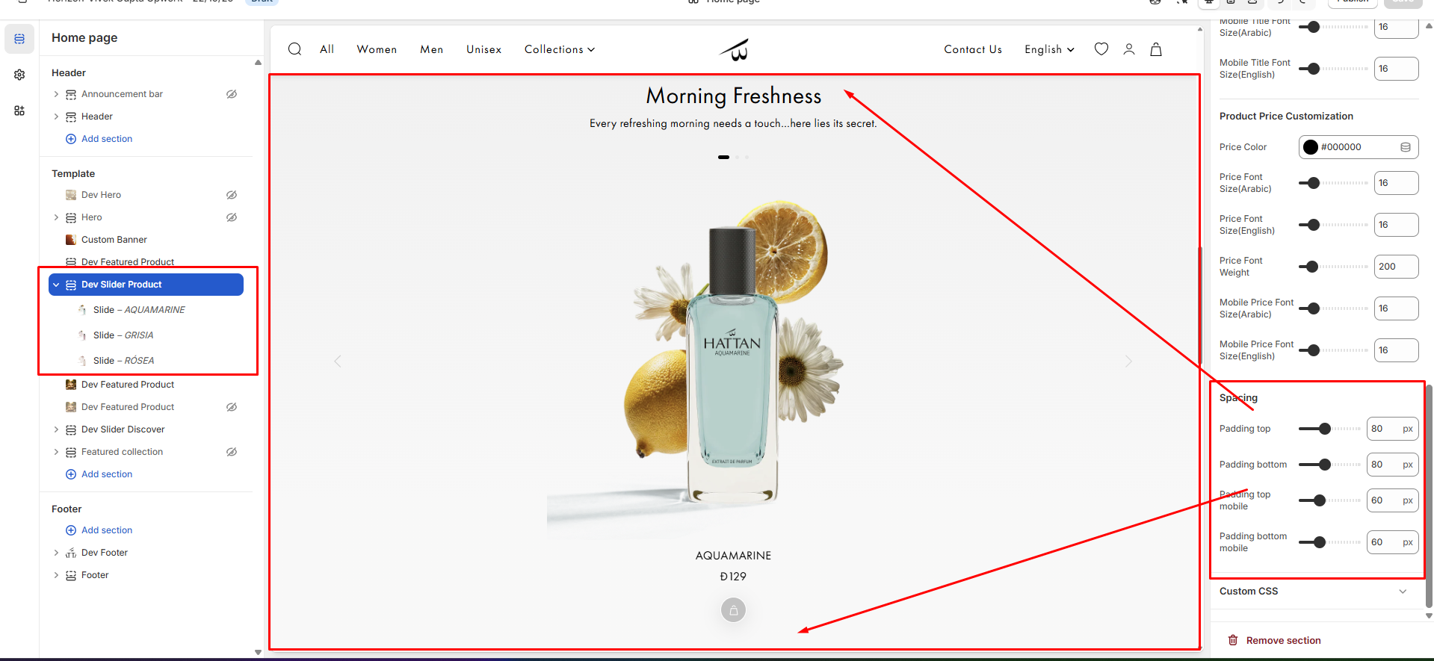
You can change the top/bottom spacing both for mobile and desktop screens using the option marked above in the screenshot.
======================================================================
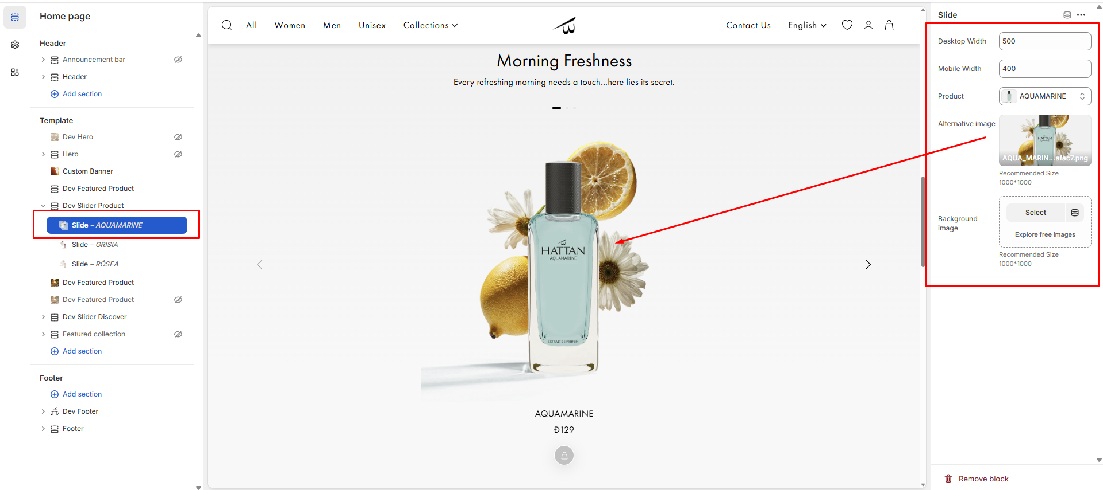
You can change the background image, image, select the product. width both for mobile and desktop screens using the option marked above in the screenshot.
======================================================================
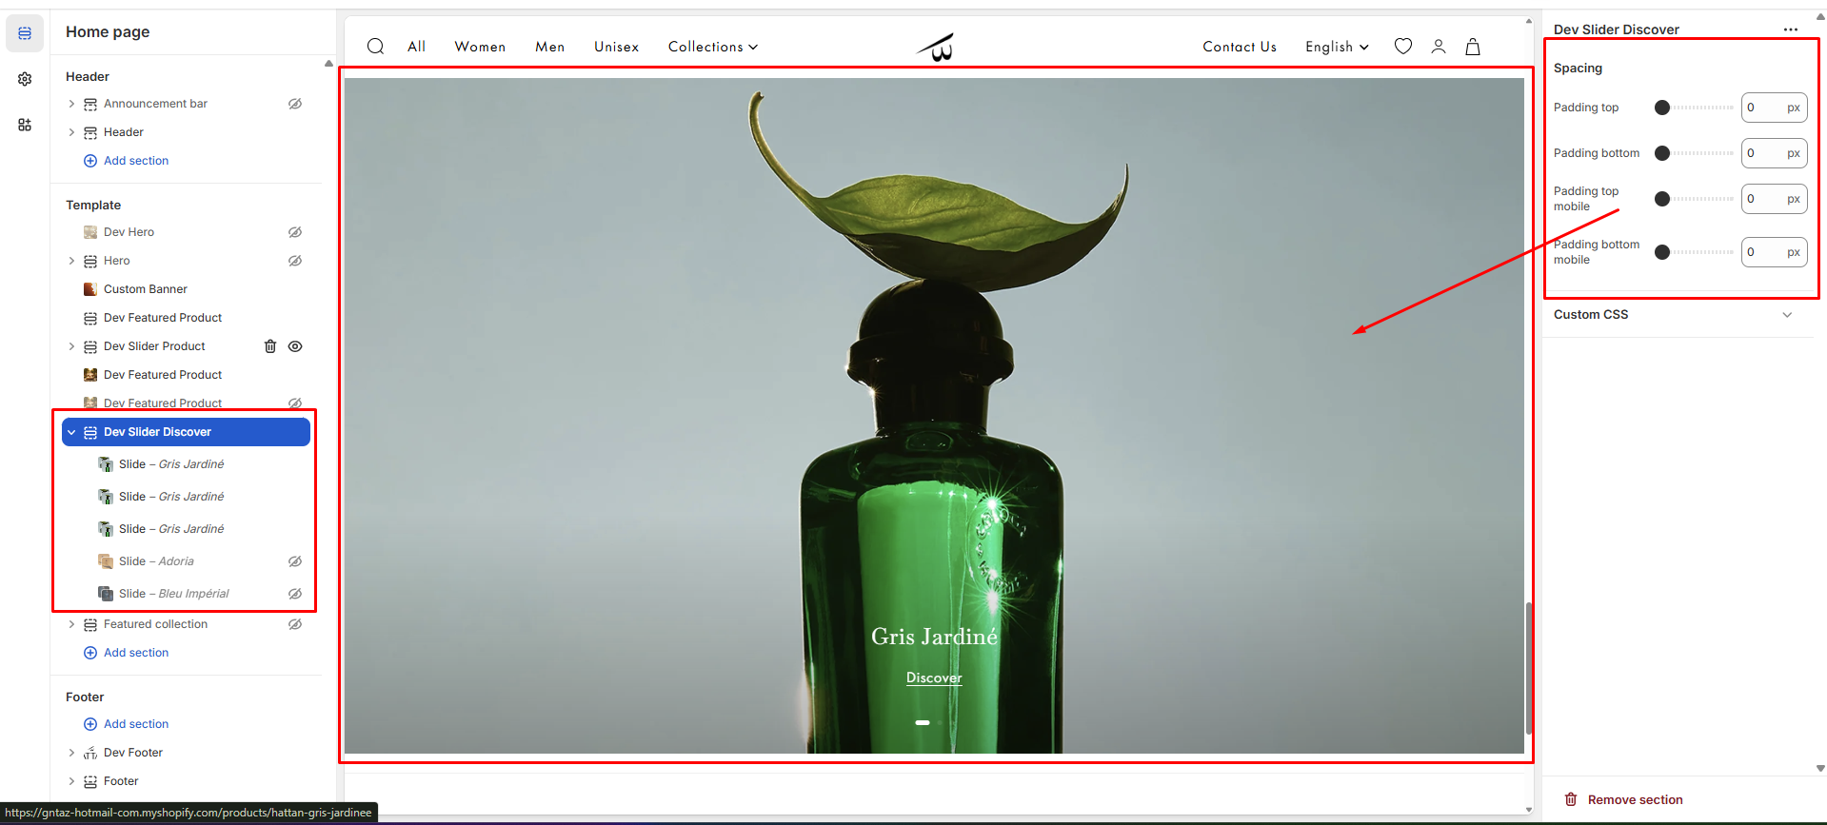
You can change the top/bottom spacing both for mobile and desktop screens using the option marked above in the screenshot.
======================================================================
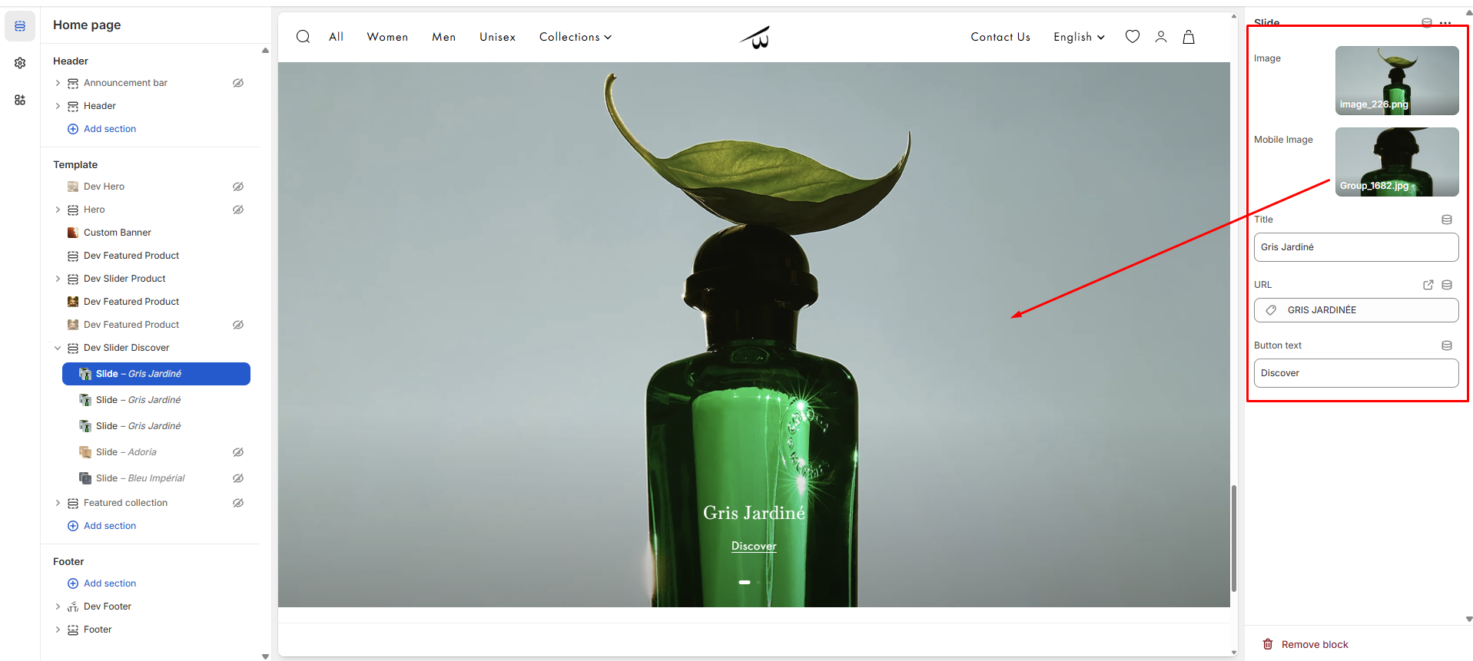
You can change the title, url, the button label, image both for mobile and desktop screens using the option marked above in the screenshot.
======================================================================

