Hattan (Maison Hattan)
{ https://hattan.co/?_ab=0&_fd=0&_sc=1&preview_theme_id=183249830202 }

1 - Custom Banner
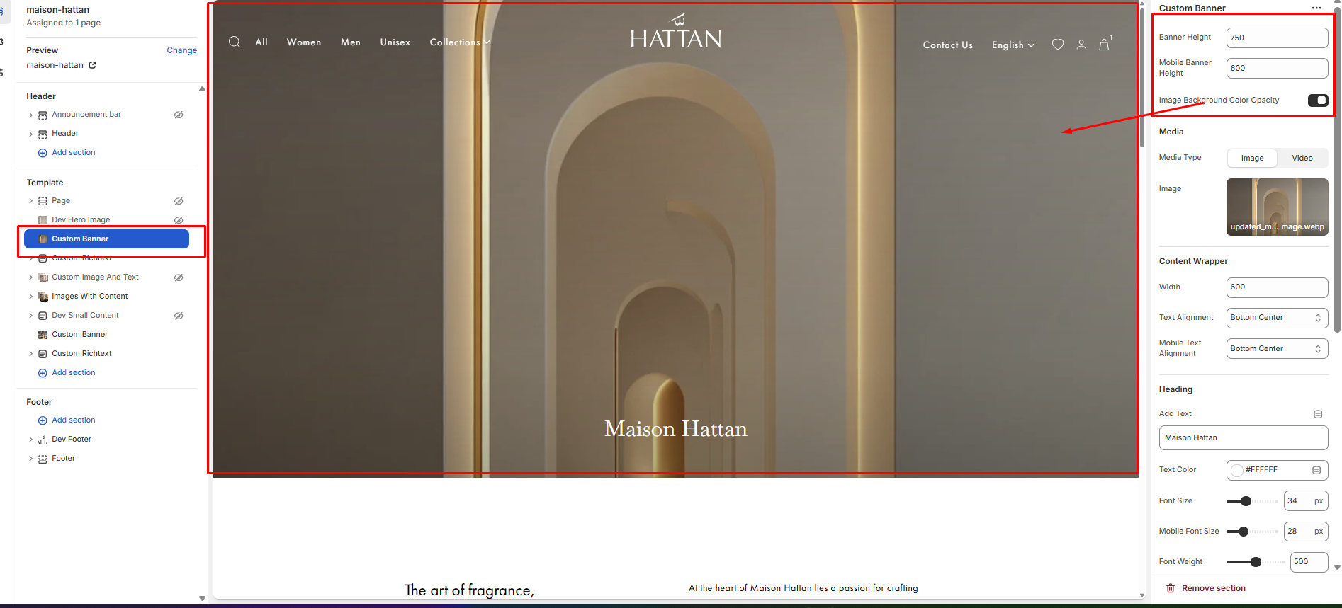
Admin can change the height of the banner for mobile and desktop screens and enable the overlay using the option marked above in the screenshot.
======================================================================
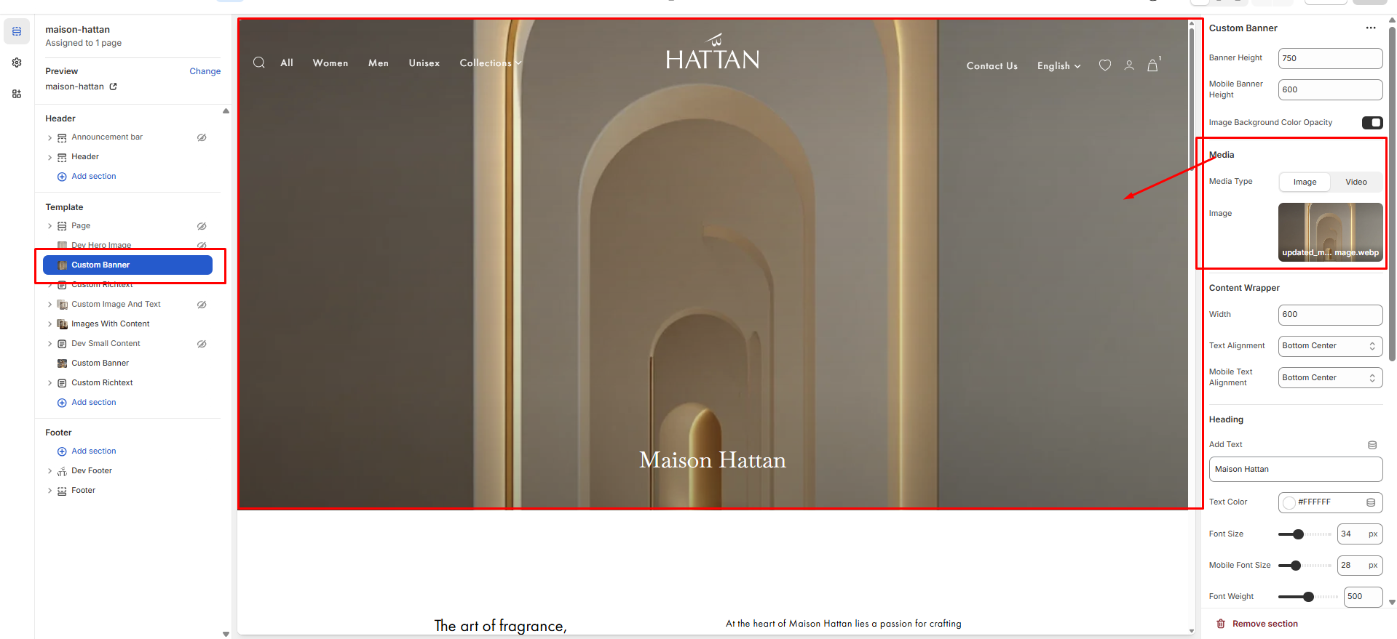
Admin can change the media type(image/video) using the option marked above in the screenshot.
======================================================================
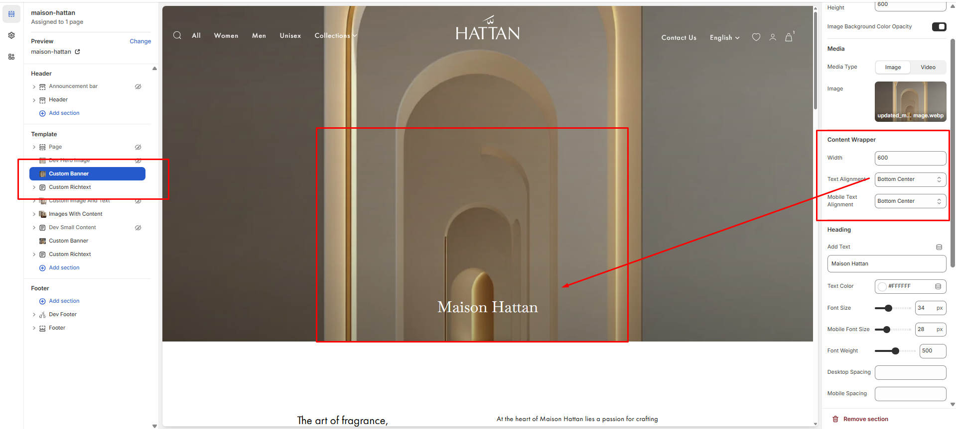
Admin can change the content width and the content position for both mobile and the desktop screens using the option marked above in the screenshot.
======================================================================

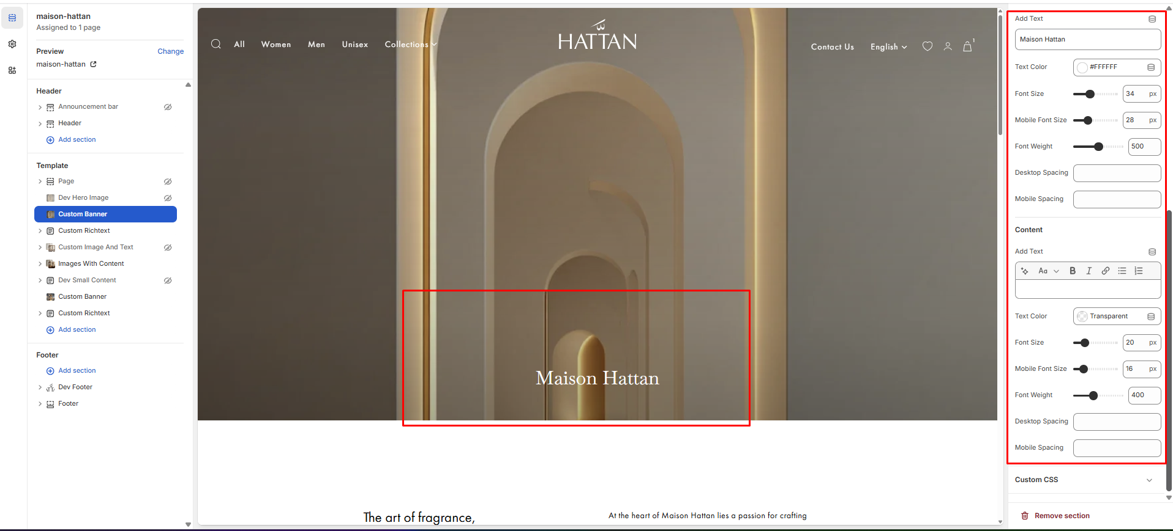
You can change the heading/text, font size, color, font weight and top/bottom spacing both for mobile and desktop screens using the option marked above in the screenshot.
======================================================================

2 - Custom Richtext
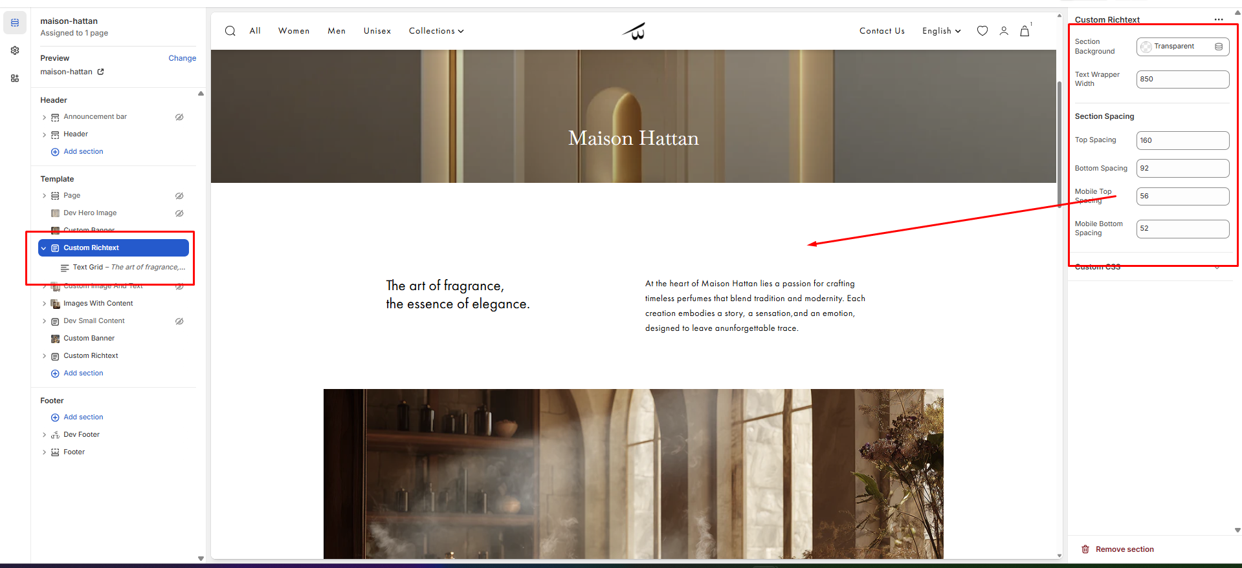
You can change the background color, max-width, top/bottom spacing both for mobile and desktop screens using the option marked above in the screenshot.
======================================================================
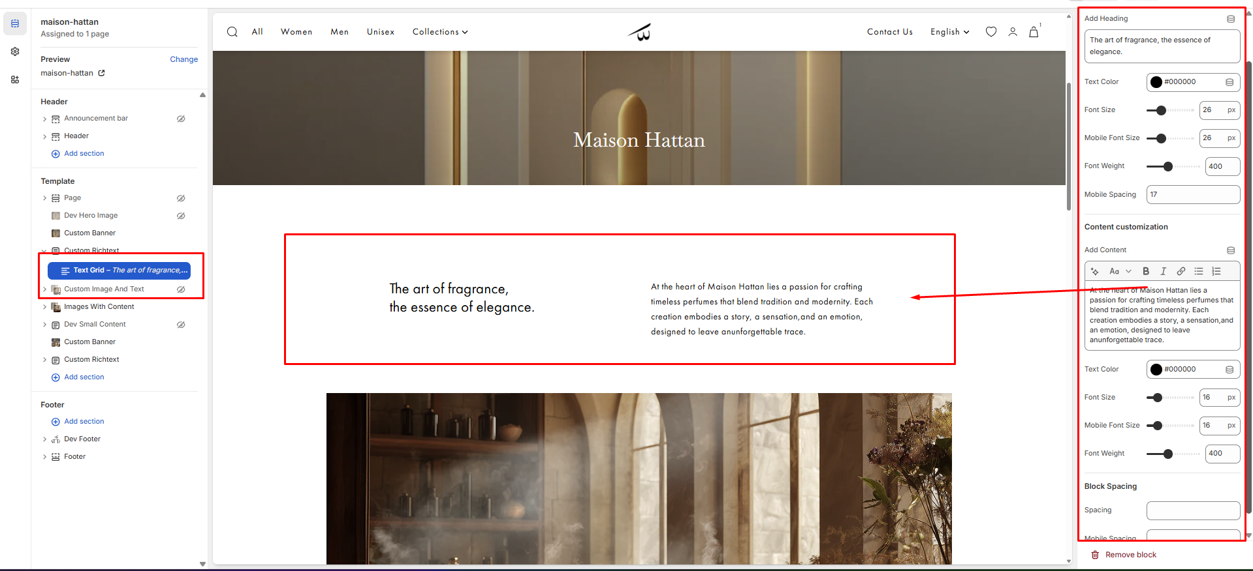
You can change the heading/content, font size, color, font weight and top/bottom spacing both for mobile and desktop screens using the option marked above in the screenshot.
======================================================================

3 - Image With Content
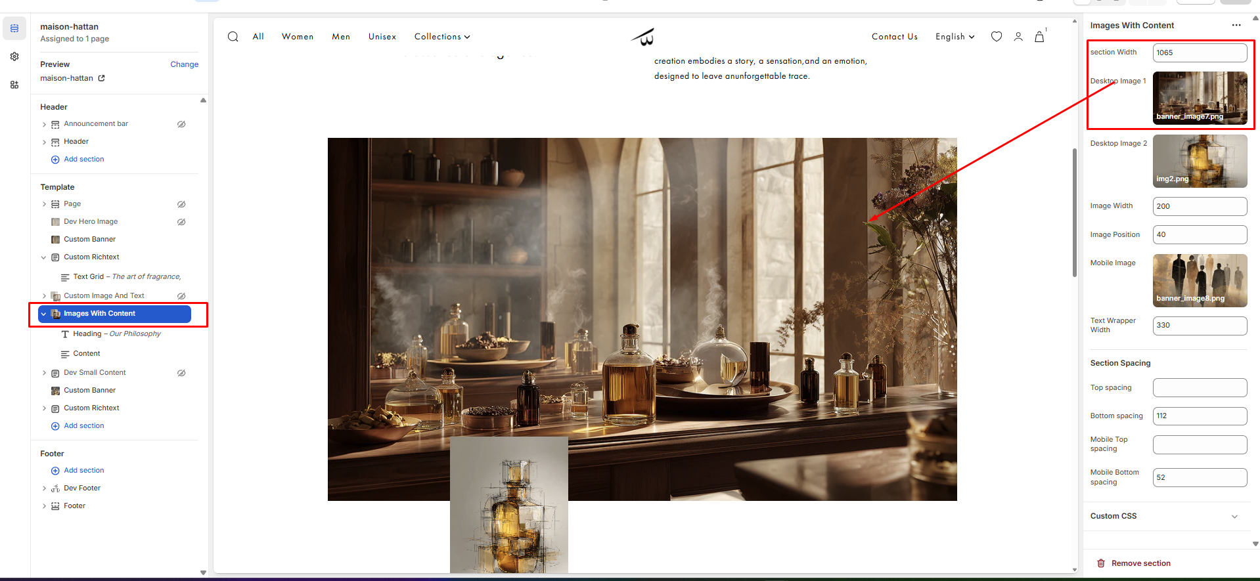
Admin can change the first image and section width using the option marked above in the screenshot.
======================================================================
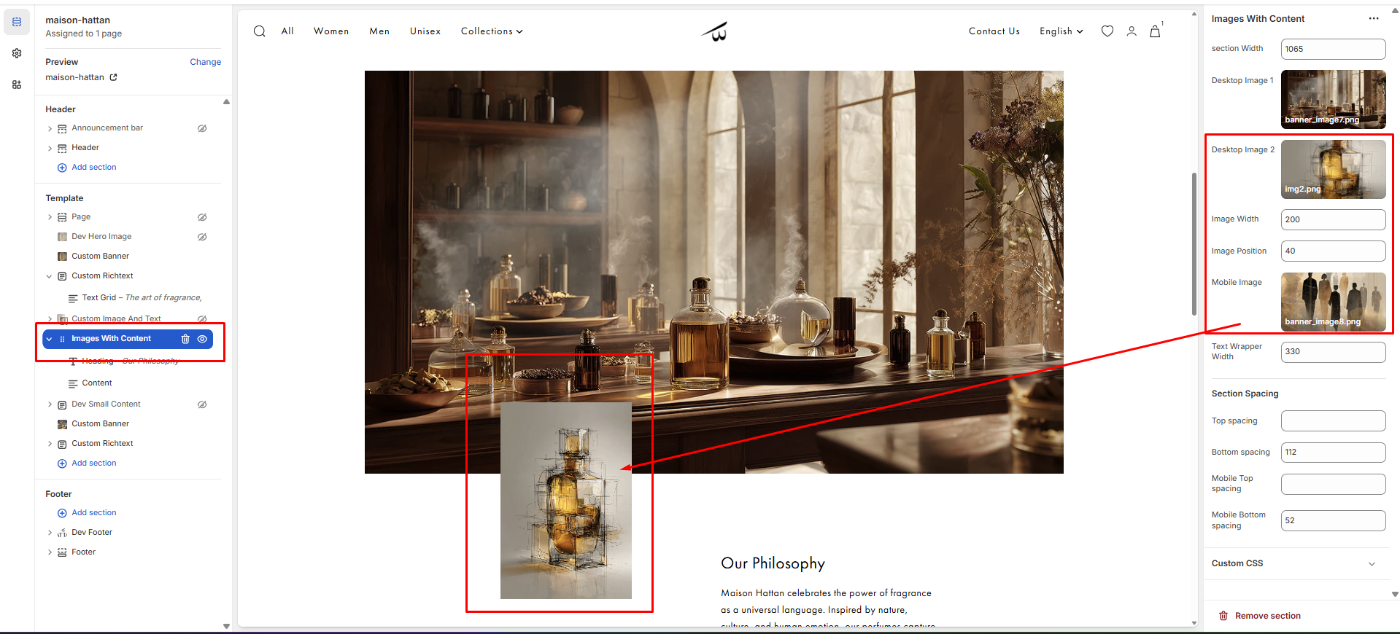
Admin can change the second image, its width, and its position from the top, as well as update the image displayed on the mobile screen using the option marked above in the screenshot.
======================================================================
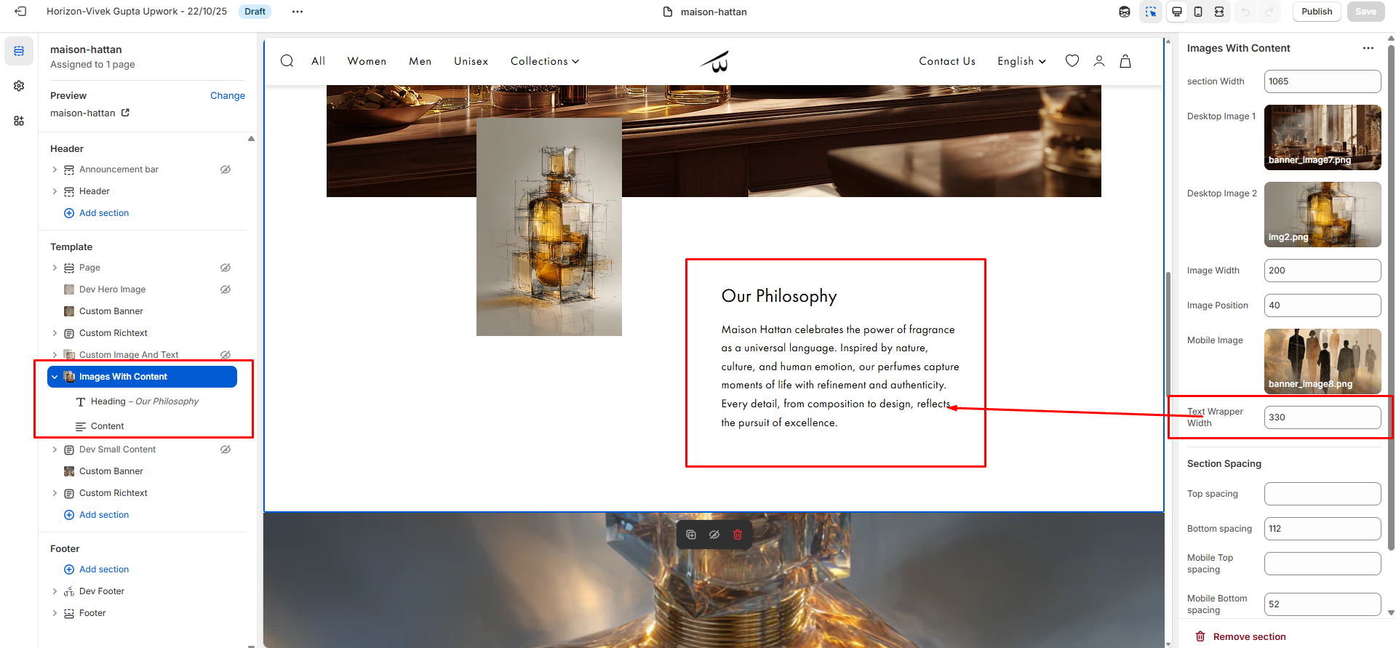
Admin can change the text width using the option marked above in the screenshot.
======================================================================
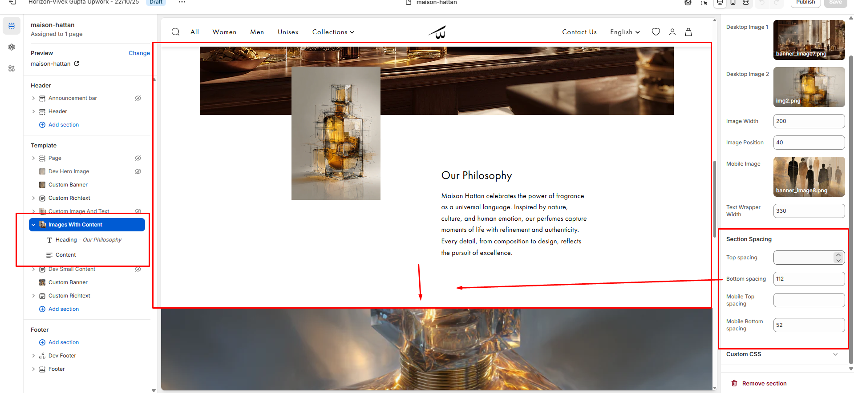
You can change the top/bottom spacing both for mobile and desktop screens using the option marked above in the screenshot.
======================================================================
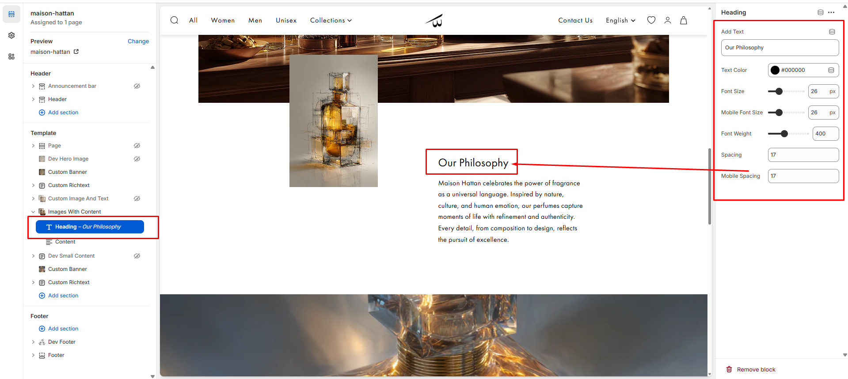
You can change the heading, font size, color, font weight and top/bottom spacing both for mobile and desktop screens using the option marked above in the screenshot.
======================================================================
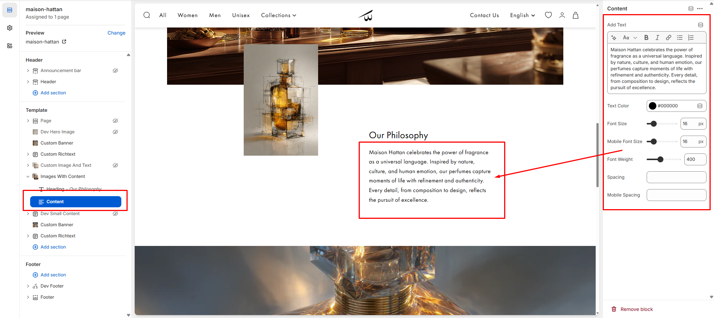
You can change the content, font size, color, font weight and top/bottom spacing both for mobile and desktop screens using the option marked above in the screenshot.
======================================================================

4 - Custom banner
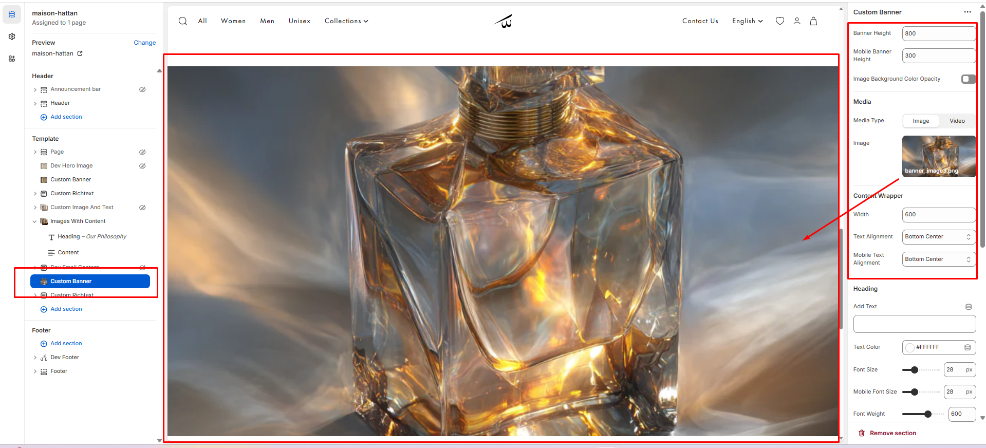
Admin can change the height of the banner for mobile and desktop screens and enable the overlay, also change the media type(image/video) using the option marked above in the screenshot.
======================================================================

5 - Custom Richtext
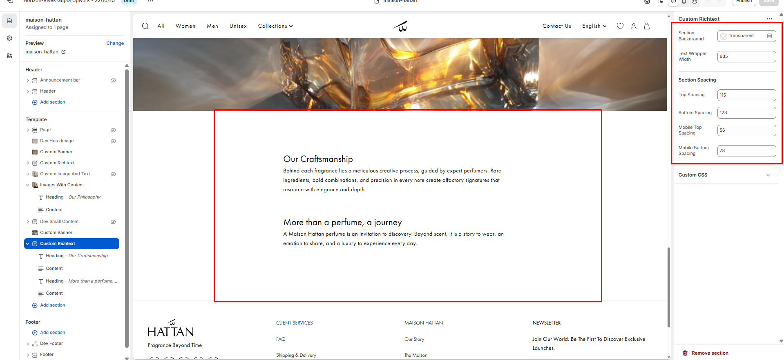
You can change the background color, max-width, top/bottom spacing both for mobile and desktop screens using the option marked above in the screenshot.
======================================================================
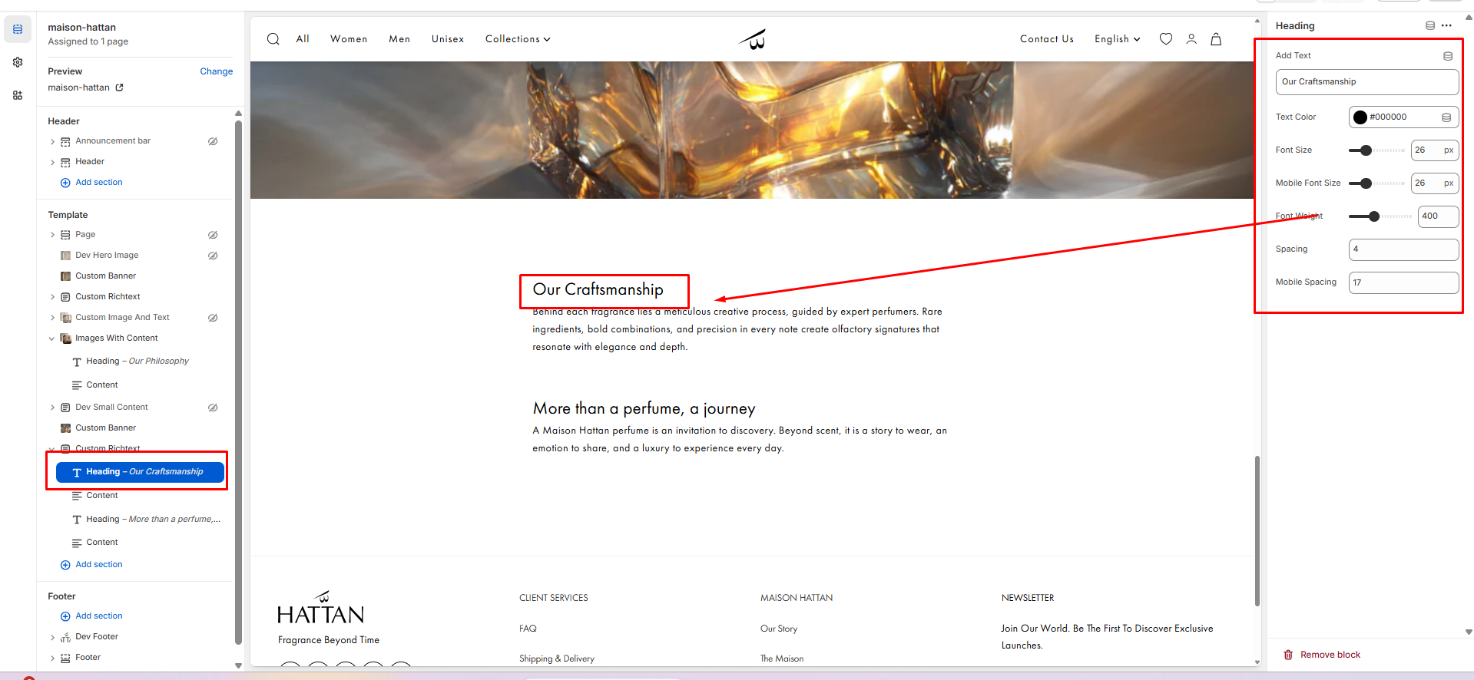
You can change the heading, font size, color, font weight and top/bottom spacing both for mobile and desktop screens using the option marked above in the screenshot.
======================================================================

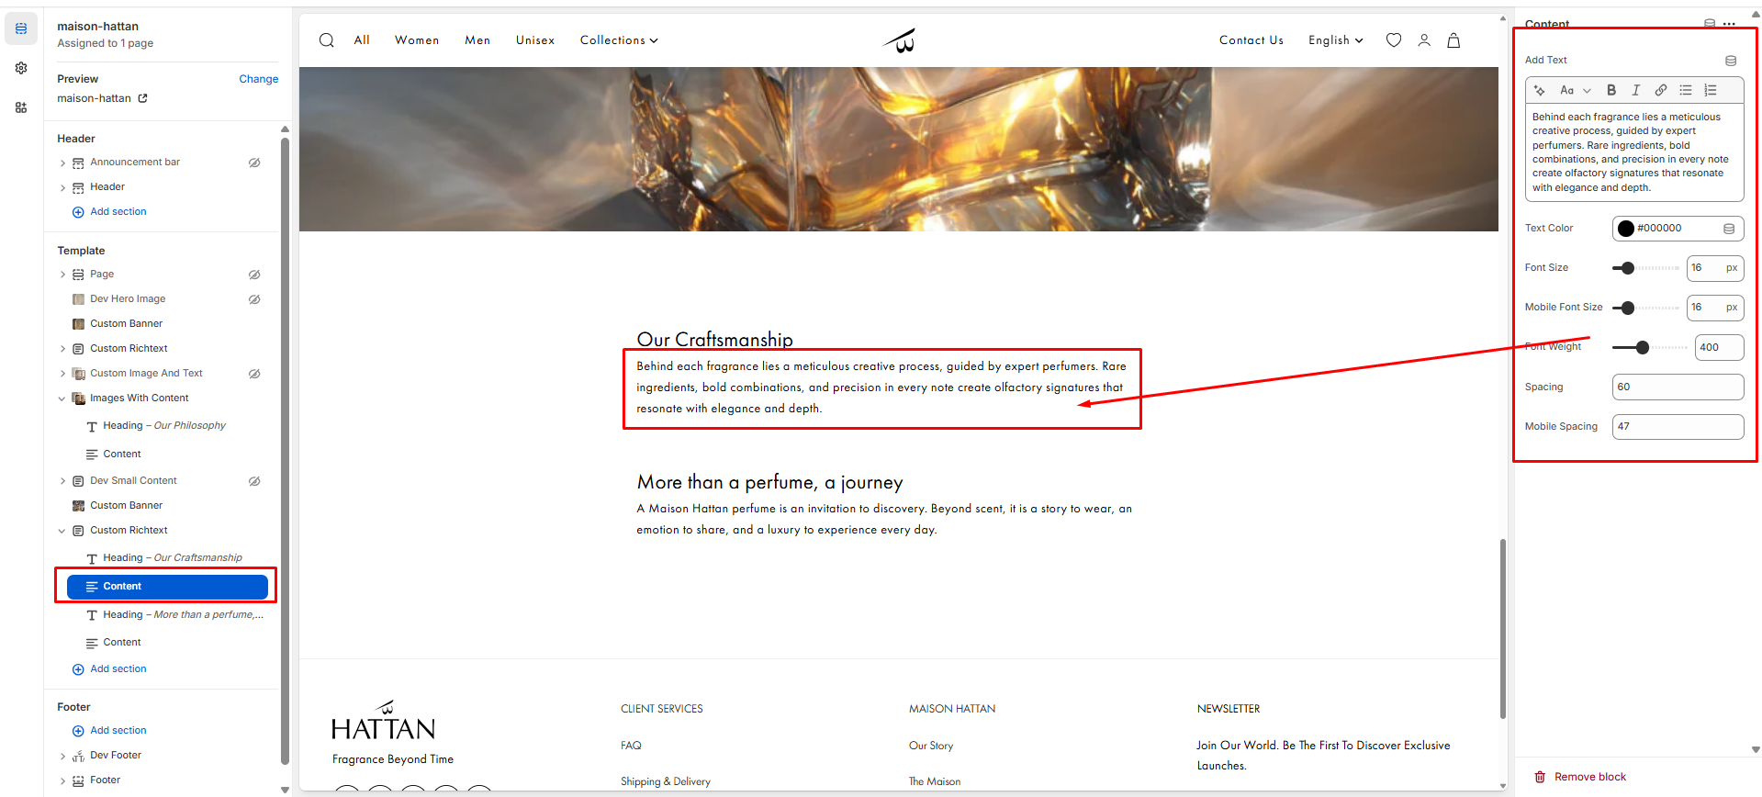
You can change the content, font size, color, font weight and top/bottom spacing both for mobile and desktop screens using the option marked above in the screenshot.
======================================================================

